**OFF-GRID POWER SYSTEM**

by Durgesh Kolte

**\*Solar Panel\***

Location: **Pune**

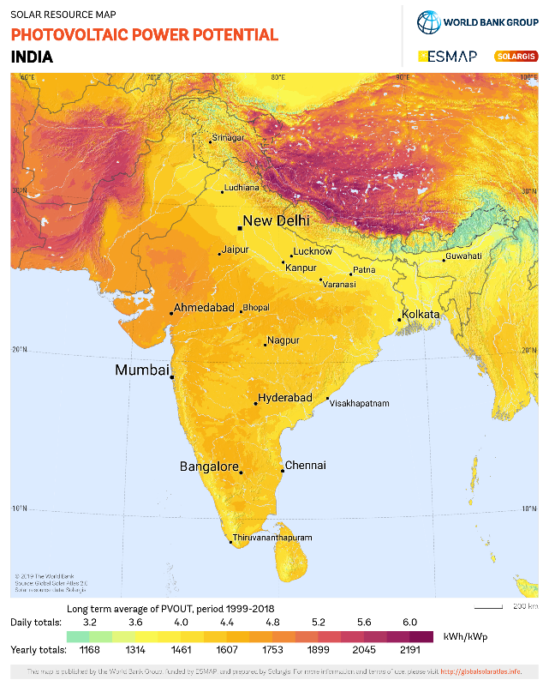

## **LITHIUM-ION 18650 RECHARGEABLE CELL 3.7V 1500MAH (2C) Rs.70**

<https://robokits.co.in/batteries-chargers/skycell-li-ion-battery/3.7v-li-ion-batteries-3.2-4.2v/run-lithium-ion-rechargeable-cell-3.7v-2200mah-not-for-industrial-use?cPath=13_251&>

# **Electronicspices- 10 Watt - 6 Volt Solar Panel**

<https://www.amazon.in/Electronicspices-10-Watt-Solar-Panel/dp/B07PVVF5FS>

**\*TP4056 Li-ion charge Protection\***

<https://robokits.co.in/batteries-chargers/charge-protection-circuit/tp4056-1a-5v-li-ion-battery-charging-module>

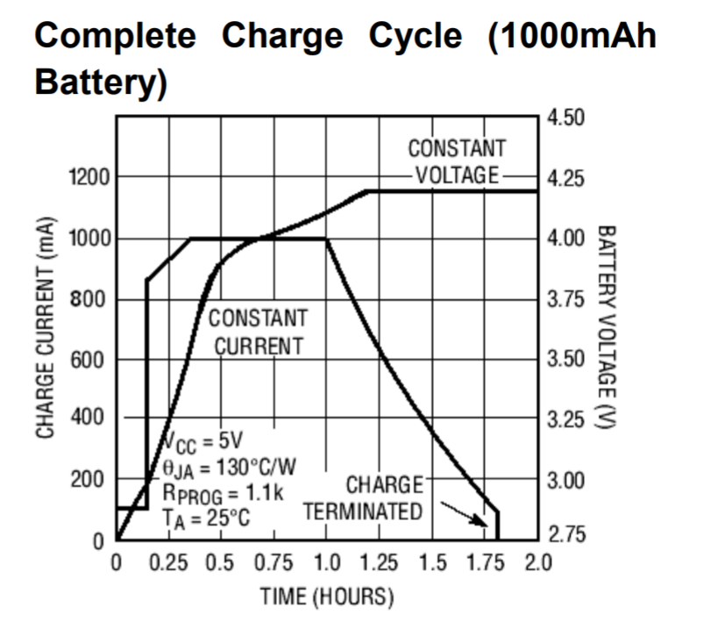

[5:58 PM, 6/24/2020] Durgesh Kolte: *NodeMCU Current reference*

<https://arduino.stackexchange.com/questions/37641/nodemcu-power-consumption-measurement-and-deepsleep>

<https://docs.zerynth.com/latest/official/board.zerynth.nodemcu2/docs/index.html>

*Datasheet*

<https://www.espressif.com/sites/default/files/documentation/0a-esp8266ex_datasheet_en.pdf>

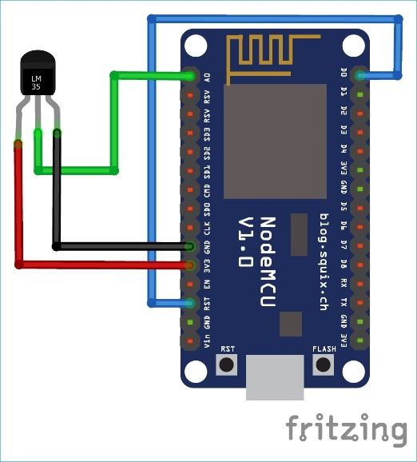Pin Diagram for Sleep Mode:

External Guide Link:

<https://circuitdigest.com/microcontroller-projects/esp8266-deep-sleep-mode-programming-explanation>

YouTube Link for guide to Sleep Mode:

<https://youtu.be/QQrFxn6G97Y>

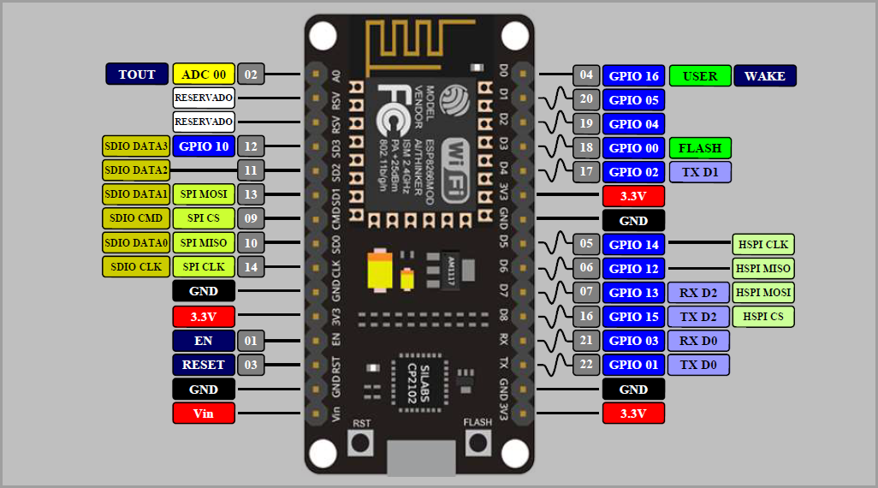

[6/26, 5:45 PM] Durgesh Kolte: Reference

<https://bitluni.net/solar-powered-weather-station>

<https://www.youtube.com/watch?v=WdP4nVQX-j0>

<https://www.geekstips.com/esp8266-arduino-tutorial-iot-code-example/>

<https://medium.com/electronza/esp8266-running-on-battery-power-89fc124d08a4>